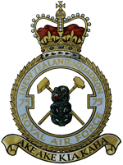

Information in connection with photos and images

75 Sqn RNZAF

Lancaster - No75 NZ PB820-JN-V

- 01/02 - 1945, Photo taken from English Magazine. Crew Unknown, 75 Sqd New Zealand.

- 03/04 - Doug Clements Lancaster V-JN taxiing out, Mepal.

- 05 - Letter from Ron Hewitt confirming crew for the presentation of art work by Maurice Conly showing V-JN over Channel Ports.

- 06/07 - Placed above Art Work - 'Presented to the New Plymouth R.S.A - Artwork by Maurice Conly'

