RALPH'S MEMORIAM INSERTED IN THE TARANAKI HERALD ON THE 25th JULY 1918
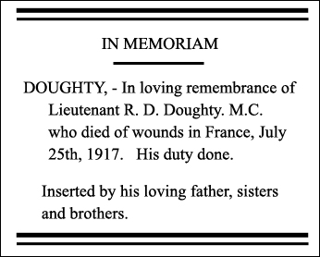
EPILOGUE
Here ends the last known diary entry of Lieutenant Ralph Dorchell Doughty.
It seems unlikely to me that Ralph would have given up writing entries in his set of diaries, having done so almost continuously since the 5th April 1915. This would have been his sixth diary, and if it existed it would have covered the remainder of March, all of April, May, June and most of July 1917, up until he was "wounded in action" on the 23rd July 1917. To then die of wounds received on the 25th July 1917. The reason for him not continuing with his diary entries is not known, maybe his commitment to army life did not allow Ralph to make anymore entries in any his diaries.
'I personally would like to think that if there was another diary that it is with Ralph when he was laid to rest in Coxyde Military Cemetery'
And it is with the greatest honour and respect that Ralphs set of diaries are now being looked after by members of the Kivell family so that his memory will never be forgotten. R.I.P.
P.Kivell
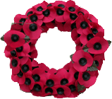
Siegfried Sassoon wrote:
"...I died in Hell (they called it Passchendaele) my wound was slight and I was hobbling back;
and then a shell burst slick upon the duckboards; so I fell into the bottomless mud, and lost the light"

