Remembering a fallen Kiwi soldier 100 years on

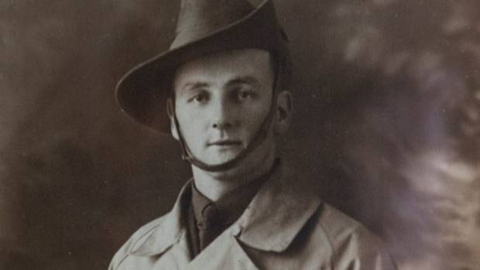

Ralph Doughty, who was killed 100 years ago in World War I.
In the early hours of July 23, 1917, two young lieutenants met in the aftermath of a gas shell barrage during the battle of Passchendaele that had caused up to 2,000 casualties.
New Zealander Ralph Doughty, a war hero who was awarded the Military Cross, and Australian Ken Kingsmill were heading to a command post in the Belgian town of Nieuport, on the Western Front, to seek instruction in the wake of the assault.
Suddenly Doughty fell fatally wounded, a moment recorded by Kingsmill in his diary. It's an entry that serves as a snapshot of the indiscriminate killing.
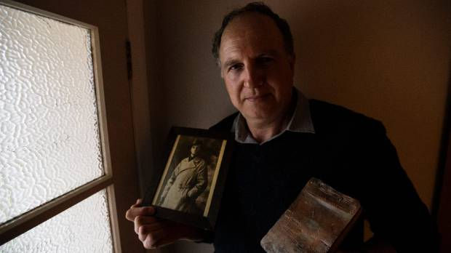
ANDY JACKSON/STUFF
New Plymouth man Peter Kivell has the war diaries of his great-great uncle Ralph Doughty, who was killed 100 years ago in the First World War.
"About 3.30am, when things slackened a little, I went over to the control pit to see if any news had been received as to what was going on and, as I came round one side, Lieutenant Doughty came round the other and we met at the entrance to the pit.
"He put his hand behind me and said 'Go on, hop in Kingie', which I did. He fell in behind me."
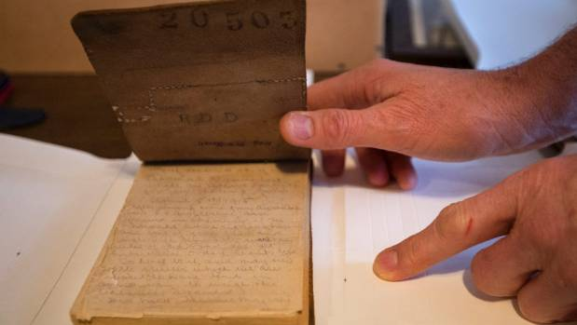
ANDY JACKSON/STUFF
One of Ralph Doughty's diaries.
At that moment, one of the 12th Brigade guns just behind them fired prematurely and sent a splinter into Doughty's back and out his stomach.
"We got a stretcher, cut down the gas curtain, and sent him off to the dressing station. He was a fine man and a very well-liked officer."
A century on, Doughty, a Gallipoli veteran, is being remembered by his descendants
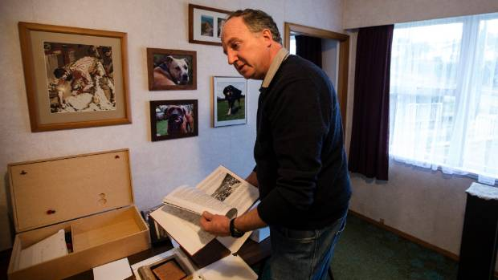
ANDY JACKSON/STUFF
Peter Kivell is remembering his great, great uncle Ralph Doughty, who was awarded the Military Cross in World War I.
Like Kingsmill, the Taranaki-born soldier kept diaries.
"As soon as there was a battle or something he'd write it down straightaway," says Peter Kivell, Doughty's great-great nephew, as he takes five notebooks out of their wooden box at his New Plymouth home.
The pencil entries, fading after more than a century, tell the story of a young man who had left rural Stratford for Australia, eventually joining the Australian Field Artillery Brigade as a bombardier.
Unlike the images of horror usually associated with the war, Doughty appears to have taken the experience in his stride, earning the Military Cross in 1917 for, "bringing artillery fire on the enemy at a critical time".
In places his diaries read like a grand adventure that took him to Egypt, Gallipoli, England, France and Belgium.
At Gallipoli on November 25, 1915, he wrote: "Bitterly cold again. Last night 5 Turks managed to get through our lines, but were met in Monash Gully by some of the lads. The Turks, not the 'lads', went west."
And while on the Western Front on March 4, 1917, he noted: "An awfully funny thing happened with a patrol of ours consisting of 4 men. They were out in NML (no man's land) and got caught by a Hun Patrol of 40 who took them prisoners anyhow both parties got lost in the mist, finally they all walked into our own lines, and we bagged 40 Huns without a casualty."
The diaries are filled with such details, says Kivell. "He came ashore at Gallipoli under fire – and wrote that in straight away. He got quite upset when he got sent back to the ship because he wanted to go with the boys."
In the hours after Doughty was injured there was hope he might survive. But on July 25, a rainy and dull day, Kingsmill "got word that Doughty had died at the 15th Corps Dressing Station".
He was 26 years old.
In all, more than 120,000 New Zealanders enlisted - a tenth of the country's 1.1 million population - and 18,000 died.
Kivell grew up with Doughty's first diary.
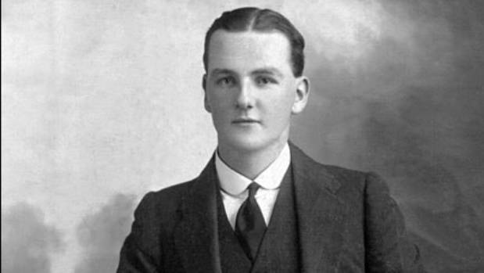
Ralph Doughty, of Stratford, Taranaki, was awarded the Military Cross for his heroic actions in World War One.
"My father was actually given this when he was a young boy," he says, holding that first journal and pointing out the leather binding, which probably came from a horse saddle.
"And when his mother passed away there was another set of diaries that were locked away that he didn't know about."
Eventually the family was reunited with five of Doughty's journals, which stop on March 16, 1917.
Why did he stop writing them? "I've no idea," says Kivell. "There may be a sixth one around."
A relation, Jane Webster, transcribed the entries and Kivell put them online.
Ken Kingsmill's son, Donald, saw the website, thekivellfamily.co.nz, and got in touch to share his father's journals.
"Donald Kingsmill knows that without Ralph mentioning those five words, "Go on, hop in 'Kingie",' he and his family would not be here today," says Kivell.
In 2011 the Kingsmill family visited Doughty's resting place at Coxyde Military Cemetery in Belgium, just as Ken Kingsmill had done after the funeral.
This Tuesday, 100 years to the day of his death, Doughty's great niece, Wendy Braniff, is staging a memorial servicein Standown Park, near Tin Can Bay in Queensland.
A letter from the New Zealand High Commissioner Chris Seed, praising Doughty and the family that honours him, will be read out.
Although Peter Kivell will not be able to attend, he will mark the date with his family in Taranaki.
They will visit Stratford cemetery, where Doughty's parents are buried, and where the fallen soldier has a remembrance stone. They will take his diaries with them and reflect.
"I will be with my parents, and remembering Ralph's service," Kivell says. "He will be remembered."

