Ralph is remembered 100 years on
A soldier of the First World War is being remembered by family members in New Plymouth and Australia, exactly 100 years after he was killed
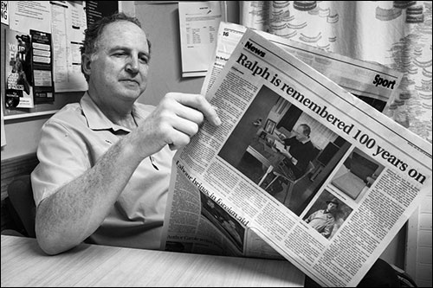Lieutenant Ralph Doughty was only 26 years old when he died on July 25 1017 – two days after he was hit by shrapnel during the battle of Passchendaele. He was buried at Coxyde Military Cemetery in Belgium.
The Military Cross winner, of Stratford, kept diaries throughout his was service and these are now treasured by his great-great nephew, Peter Kivell, of New Plymouth.
Tomorrow, on the centenary of Doughty’s death, Peter Kivell plans to visit his remembrance stone in Stratford Cemetery, where Doughty’s parents were laid to rest and reflect.
“I will be with my parents, and remembering Ralph’s service, Kivell said, ‘he will be remembered’.
Meanwhile, some 40 relations from another branch of the family will gather for a memorial service in Standown Park, near Tin Can bay, Queensland.
The event has been organised by Wendy Braniff, Kivell’s distant cousin, and will be attended by relatives from parts of Australia and New Zealand.
“I am blown away by the response,” she said. “It would seem people do want to remember this man and pay tribute to him”.
She has also received a letter from the former New Zealand High Commissioner, Chris Seed, which praises both Doughty and the family that honour’s him.
“Lt Doughty’s military record alone – from his enlistment in August 1914 at the very outbreak of the Great War until his death at Passchendaele 100 years ago this week – speaks to his courage and his commitment to country, family and mates,” write Seed in the letter, which will be read out during the gathering.
Doughty died in the aftermath of a gas shell barrage that had caused up to 2,000 casualties.
He and Lieutenant Ken Kingsmill, of Australia, were heading to a command post in the Belgium town of Nieuport to seek instruction in the wake of an assault.
As Kingsmill wrote in his diary: “About 3.30am, when things slackened a little, I went over to the control pit to see if any news had been received as to what was going on and, as I can around one side, Lieutenant Doughty came round the other and we met at the entrance to the pit.
“He put his hand behind me and said ‘Go on, and hope in Kingie’, which I did. He fell in behind me.”
At that moment, one of the 12th Brigade guns just behind them had fires prematurely and sent a splinter into Doughty’s back and out his stomach.
“We got a stretcher, cut sown the gas curtain, and sent him off to the dressing station. He was a fine man and a well-liked officer.”
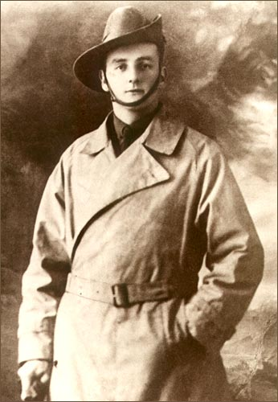Like Kingsmill, Doughty kept diaries which have been passed down the family. “As soon as there was a battle or something he’d write it down straight-away,” said Kivell. “The shell count, how many shells he fired, and what type they were etc. He came ashore at Gallipoli under fire – and wrote that is straight away. He got quite upset when he got sent back to the ship because he wanted to go with the boys.”
In all, more that 120,000 New Zealanders enlisted – a tenth of the country’s 1.1 million population – and 18,000 died. A further 41,000 were wounded.
Unlike the images of horror usually associated with the war, Doughty appears to have taken the experience in his stride, earning the Military cross in 1917 for, “bringing artillery fire on the enemy at a critical time”.
He had gone from sleepy, rural Stratford to Australia to seek better prospects, eventually joining the Australian Field Artillery Brigade as a bombardier.
War broke out on July 1914 and the following month he joined the Australian Field Artillery Brigade.
In places his diaries read like a grand adventure that took him to Egypt, Gallipoli, England, France and Belgium.
At Gallipoli, on November 25, 1915, he wrote: “Bitterly cold again last night. Got back some unearthly hour this morning but saw noting of our Howitzers. Last night 5 Turks managed to get through our lines, but were met in Monash Gully by some of the lads. The Turks, not the ‘lads’, went west.
And while on the Western Front on March 4, 1917, he noted: “Managed to get my hair cut today. Not before I wanted it either. Still cold, but fine. Very heavy shelling on the right early this morning.
“An awfully funny thing happened with a patrol of ours consisting of 4 men. They were out in NML (no man’s land) and got caught by a Hun Patrol of 40 who took them prisoners anyhow both parties got lost in the mist, finally they all walked into our own lines, and we bagged 40 Huns without a casualty.”
Kivell said he grew up with Doughty’s first diary, which had been given to his father, Tony. “When Tony’s father passed away there were another set of diaries that were locked away that he didn’t know about, (this being diary two, three, and five, diary four was missing from the set and only discovered in mid 1985).”
A relation Jane Webster transcribed the entries and Kivell put them online.
Many details of Doughty’s death only came to light when Ken Kingsmill’s son, Donald, saw the website thekivellfamily.co.nz and got in touch to share his father’s journals, which told of Doughty’s fatal injury.
According to the entries, there had been hope Doughty might survive.
“Had news that Doughty was doing well,” Kingsmill wrote later that day after catching a couple of hour’s sleep.
But on July 25, a rainy and dull day, Kingsmill “got word that Doughty had died at the 15th Corps Dressing Station”.
Kivell said he had been fascinated to learn how his relation had died and how Lieutenant Kingsmill had visited Doughty’s grave a couple of weeks after his funeral.
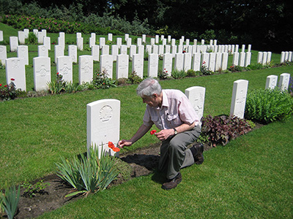In 2011 Donald Kingsmill also paid a visit to Doughty’s last resting place in Coxyde Military Cemetery. Said Kivell: “Donald Kingsmill knows that without Ralph mentioning those five words, “Go on hop in Kingie”, he and his family would not be here today.”

